**ITEC 4200 Advanced Database Semester Project**

Student Name: Samuel Groom

Semester: Fall 2019

Name of Project: Sandwich Shop

Email: Sgroom@ggc.edu

Phone number: 404-759-6653

**EXECUTIVE SUMMARY**

# Objective

This database is designed to assist **Sandwich Shop** in keeping track of the sandwiches, workers, ingredients and the shipments.

# Goals

The goal with this database project to provide a clean and organized way of storing and retrieving important data that’s important a small sandwich shop. Along with queries and reports that hold important information about the ingredients, sandwich makers, and the stock that can help keep better track of the company’s assets.

# Solution

The solution is the creation of multiple database tables including the relationships between those tables. The tables consist of the following: ***Makers***, ***Sandwiches***, ***Ingredients***, ***ItemOrder***, ***Stock***, and ***Stock_ItemOrder***. These tables center on the key parts of a living sandwich shop, along with an associative table Stock_ItemOrder which combines both Stock and ItemOrder. Using these tables, we can create the queries and reports that will provide the necessary information. It will be implemented in using Oracle 11g Express.

# Benefits to Users

The database will help users better understand how a sandwich shop works, besides just making sandwiches. It will help the user and company see how ordering shipments work, all the way down to what goes on a sandwich.

# Project Outline

The project will contain the following major components:

* Schema Design
* Entity-Relationship Diagram
* Table Implementation
* Queries
* Reports

# Part II. Schema Design

**ItemOrder** (Order_ID, Order_OrderDate, Order_DeliveryDate, Order_Cost, Order_PlacerFirstName, Order_PlacerLastName)

**Maker** (Maker_ID, Maker_FirstName, Maker_LastName, Maker_PhoneNumber, Maker_Age)

**Stock** (Stock_ID, StockItem_Name, Ingredients_Wasted, Ingredients_Lost, Reorder_Qty)

**Stock_ItemOrder** (OrderLine_Item, Stock_ID, Order_ID, Num_Ordered)

FK Stock_ID → STOCK

FK Order_ID→ ITEMORDER

**Sandwiches** (Item_Number, Sandwich_Type, Sandwich_DateMade, Maker_ID)

FK Maker_ID → Maker

**Ingredients** (Ingredients_ID, Meat_Type, Vegetable_Type, Sauce_Type, Bread_Type, Item_Number)

FK Item_Number → SANDWICHES

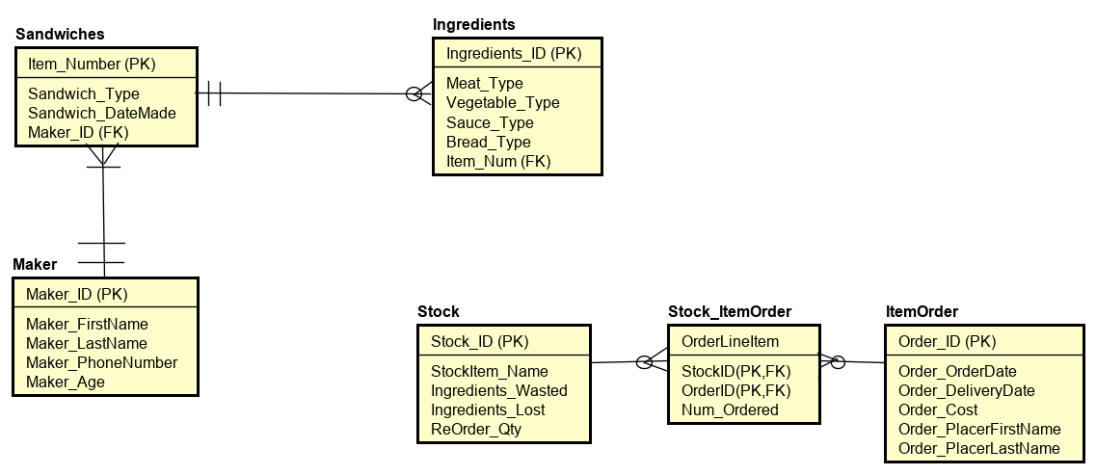

# Entity-Relationship Diagram